Practical 6

**Session Hijacking**

EditThisCookie extension:

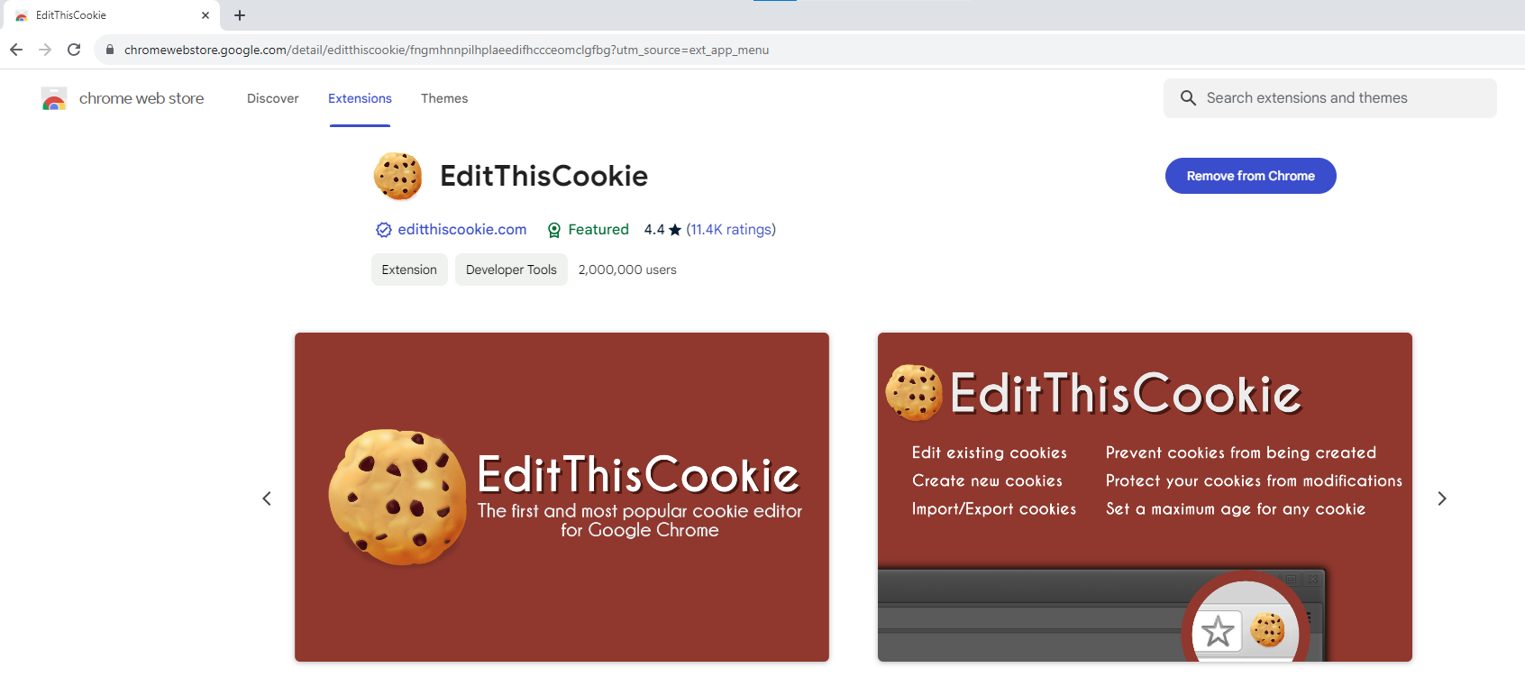

Clear all cookies

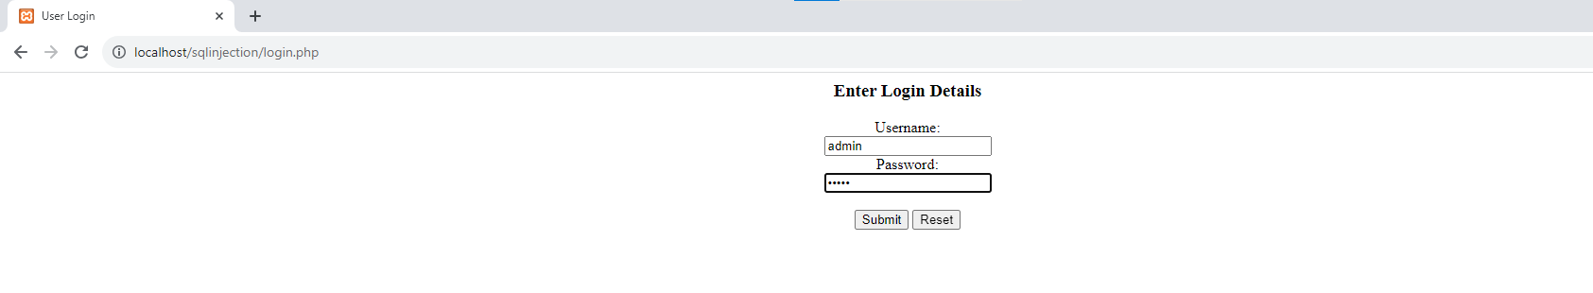

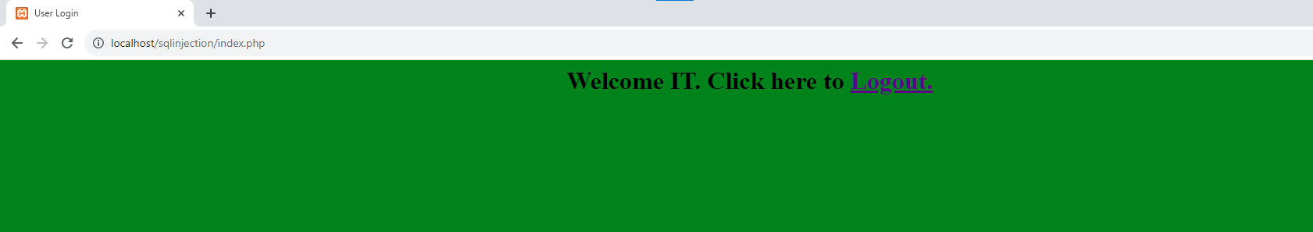

Now PHPSESSID for Admin **= ndrfddk7h1cn5ocr801n1sioef**

Next,delete the above session after it is recorded above.

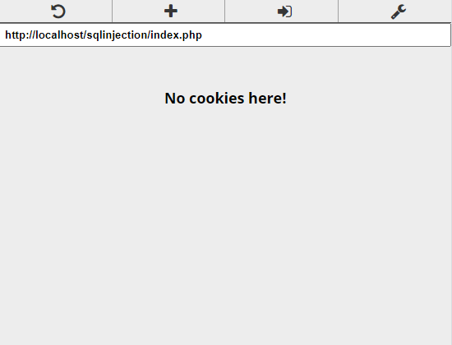

Login as username=vv and password =vv

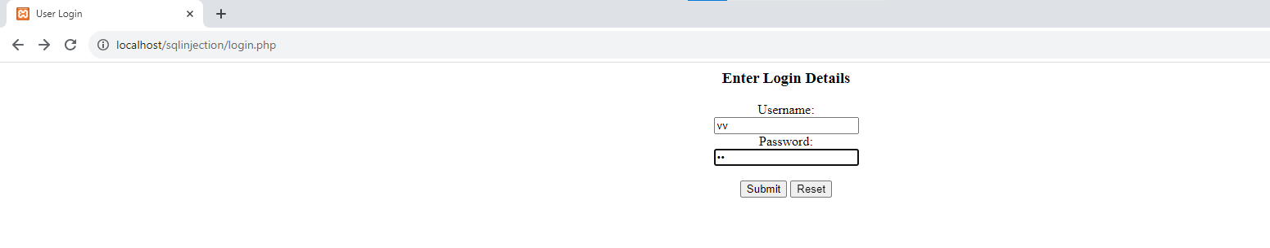

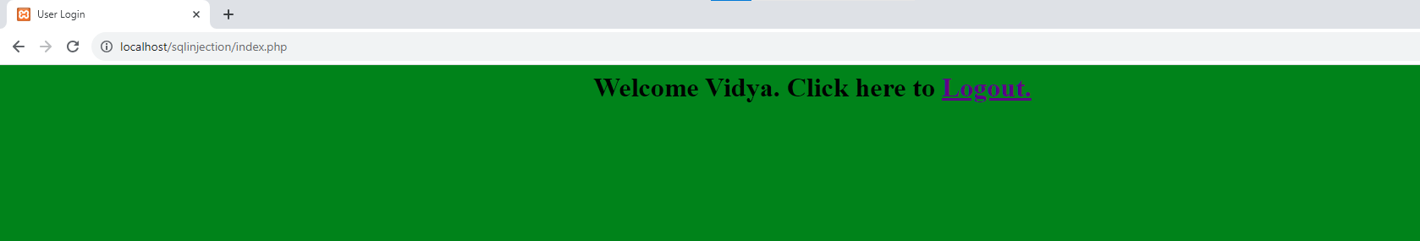

Now PHPSESSID for vv = **68sqvuhjuk4i77v0k9ca2ah7pm**

Now the admin is trying to hijack the session of username vv

In the PHPSessID replace vv’s PHPSESSID=**68sqvuhjuk4i77v0k9ca2ah7pm**

With Admin sessionid PHPSESSID= **ndrfddk7h1cn5ocr801n1sioef**

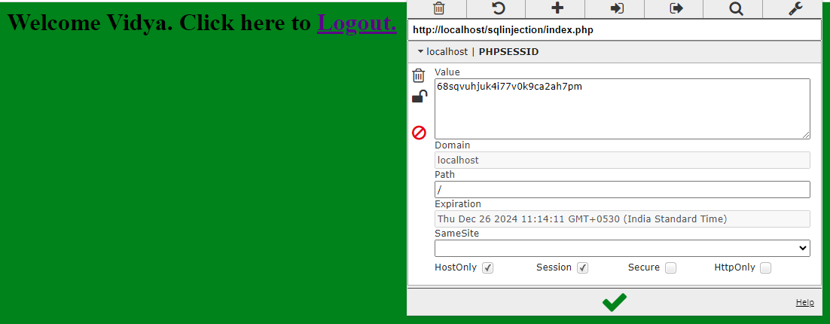

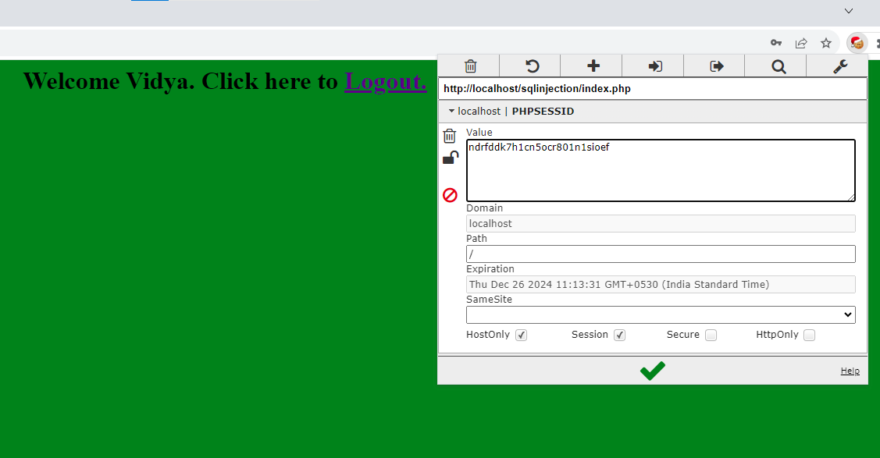

Click the green tick symbol and refresh the page

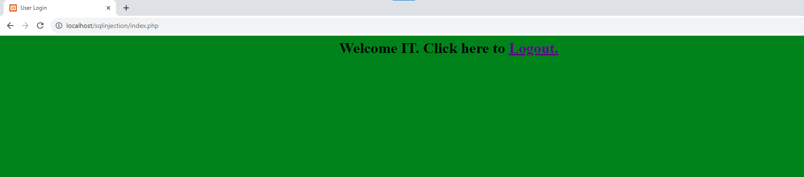

Without logging in the notice that the name is changed to IT.

What are the ways to prevent your data hacked by packet sniffers?

* Using HTTPS, the secure version of HTTP will prevent packet sniffers from seeing the traffic on the websites you are visiting.
* To make sure you are using HTTPS, check the upper left corner of your browser.
* Tunnel your connectivity to a virtual private network, or a VPN. A VPN encrypts the traffic being sent between your computer and the destination. This includes information being used on websites, services, and applications. A packet sniffer would only see encrypted data being sent to your VPN service provider.